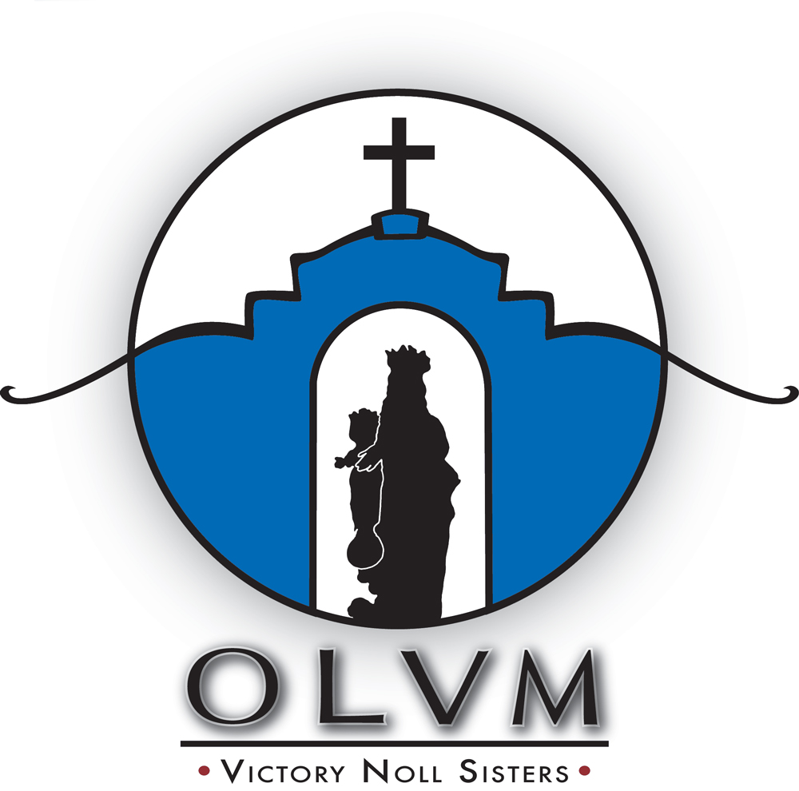


The purpose of the Empowerment Grants is to utilize our resources to effectively address the Victory Noll Sisters’ concern for those who live in poverty and are marginalized by society.

Mission Statement
We, Our Lady of Victory Missionary Sisters, rooted in a Marian and missionary spirituality, proclaim the Word of God, foster justice, stand in solidarity with those living in poverty and oppression, and promote the development of leaders.
Sisters’ lives have been marked by the core values of Hospitality, Justice, Simplicity, and Adaptability.

Grant Eligibility
The organization applying for a grant:
- Must be a not-for-profit entity classified as 501(c)3 by the Internal Revenue Service.
- Must be involved in alleviating the cause of inequality rather than the symptoms.
- Must work to empower and educate persons to a more just and peaceful society.
- Must reflect a concerted effort to benefit the poor and oppressed, to overcome poverty, to provide for educational and leadership development, to assist in other self-help or enrichment programs for personal advancement to improve the quality of life of those served by the program or project.

The Committee is looking for programs that offer systemic change and will commit support on an annual basis only. Additional support would be contingent upon program performance and re-application for funds.
Grant applications will not be accepted for building projects, medical programs, political activities, elimination of deficits, individuals, scholarships, foreign organizations, projects already completed, or organizations that are already well-funded.
Each application that is received will be judged on its own merits in conjunction with other applications submitted during the grant cycle. The granting of awards is subject to the discretion and resource limitations of the Committee.

Grant Application Deadlinę
MAY 1, 2026
- Grant requests up to $50,000 will be considered.
- Grant recipients will be notified in October. Grant funds will be distributed in November to recipients contingent upon receipt of a signed acceptance agreement.
- The Victory Noll Empowerment Grants Committee reserves the right to conduct an on-site visit of any organization that receives grant funding.
- Electronic submission is preferred.
- Please email completed application and attachments to: grants@olvm.org

GRANT APPLICATION
General Information
Name of Organization:
Address:
City: State: Zip Code
Contact Person: Title:
Telephone: E-mail:
Website: Fed. Tax I.D. #:
Executive Director Name:
Signature:
General Requirements
- Purpose of the grant — in one sentence

- Total program cost: Amount requested:
- Estimated number of individuals to be served or impacted by the program:
- Percent of low income/poor served by the program:
- Criteria used to identify “low income”:

- How did you learn of this grant opportunity?:
Proposal Narrative
- Concise overview of your organization’s history, mission, staffing, and programs.
Specify if the application is for a new program or to provide support for an existing program.
New Program? Yes _____ No ______

- Description of issue/activity to be addressed, including the target population or target activity

- How is your agency positioned to address this issue? What is unique in your approach?

- Expected outcome of action; list goals and objectives for the program and give specific measurable criteria
and timeline for successful completion.

- Expected long-term impact

- How will you determine success of action? What will be the measurable criteria for each objective?

- Proposed itemized program budget, with supportive narrative

- How will you fund this program if you are not selected to receive a grant?

General Attachments
Please include the requested documents in separate attachments.
- Current copy of 501(c)3 IRS non-profit letter, or equivalent proof of non-profit status
- List of board members, how often the board meets and if minutes are kept
- If proposal is for funding of a position, include proposed job description
- A progress report of any active grants and/or final report on any recently completed grants funded by this Committee (if not already submitted)
- Two letters of support
Financial Attachments

Please include the requested documents in separate attachments.
- Current 990 filed with IRS (including schedule B). If not required to file, then submit narrative as to why
- Most recent audit with management letter, if you do not have an audit please explain board’s expertise and procedures to ensure solid financial standing
- Current year’s operating budget with revenues and expenses
- Previous year’s budget versus actual revenue and expenses
Submission
Electronic submission is preferred.
Please email completed application and attachments to: grants@olvm.org
Application deadline is May 1, 2026. Applications received after that date will not be considered under the current funding cycle.
Grant requests up to $50,000 will be considered.
Grant recipients will be notified in October. Grant funds will be distributed in November to recipients contingent upon receipt of a signed acceptance agreement.
The Victory Noll Empowerment Grants Committee reserves the right to conduct an on-site visit of any organization that receives grant funding.

